CIOR MILITARY COMPETITION
MILCOMP COMMITTEE
FEBRUARY 2019

LIST OF ERRATA or MODIFICATIONS
Number of Errata | By | Date | Section | Remarks
1 2 - 3 - 4 - 5 - 6 - 7 - 8 - 9 - 10 - 11 - 12 - 13 - 14 - 15 - 16 - 17 - 18 - 19 | CIOR Sec | Feb 98 | 17g - 24b - 38e - 38f - 40 - 41f - 42d - 43a - 44a - 44b - 44d - 45a - 45c - 53d - 57e - 57g - 57h - 57i - 43a | Dated Feb 98
20 - 21 - 22 - 23 - 24 - 25 - 26 - 27 | CIOR Sec | Feb 99 | 42a-h - 8d-e - 9c - 16b - 8g - 14b - 25a - 29 | Dated Feb 99
28 - 29 | CIOR Sec | Feb 00 | App2 Obst12 - 4.d | Dated Feb 00
30 - 31 - 32 - 33 - 34 - 35 - 36 - 37 - 38 - 39 - 40 - 41 42 - 43 - 44 | CIOR Sec | Feb 01 | 8h - 14b - 14c - 8e - 8g - 11 - 11a - 14a - 14e-h - 32 - 38g - 44c | Dated Feb 01
45 - 46 - 47 | CIOR Sec | Feb 02 | 15a - 17b - 44d- | Dated Feb 02
48 - 49 | CIOR Sec | Feb 03 | 1a - 1d | Dated Feb 03
50 - 51 - 52 - 53 - 54 - 55 - 56 - 57 - 58 - 59 - 60 - 61 - 62 - 63 - 64 - 65 - 66 - 67 - 68 | CIOR Sec | Feb 05 | 2a - 2b - 4b - 4d - 8d - 8e - 8h - 9c - 11a - 11c - 14a - 14b - 16b - 17c - 17d - 18a - 23c - 24b - 44b | Dated Feb 05
69 - 70 - 71 - 72 - 73 - 74 - 75 | NL Del (on behalf of the Chairman) | Feb 06 | 12c - 15d - 41h - 5b - 5c - 29 - 43f | Dated Jun 06
76 - 77 - 78 - 79 - 80 | CIOR Sec | Feb 08 | 1a - 4a - 3 - 5c - 43a | NCOs included, clarifications, min. no. of CP during MOM specified
81 | CIOR Sec | Feb 09 | 13 | STANAG 1059 applied
82 - 83 - 84 | CIOR Sec | Feb 10 | 1a - 4a - 35e | Opening for all ranks, clarification on time taking on the o-course
85 | CIOR Sec | Feb 11 | 4d | Elimination of Guest category
86 - 87 - 88 - 89 - 90 - 91 - 92 - 93 - 94 - 95 - 96 - 97 - 98 - 99 | CIOR Sec | Feb 13 | 23a-b - 32 - 45a - 58 - 22c - 35a - 35b - 29 - 20a-d - 17a - 1d - 9 - 40 - 50 | Several clarifications based on TD reports 2009-2012
100 – 101- 102 – 103 – 104 – 105 – 106 – 107 – 108 – 109 – 110 – 111- | Chairman Milcomp | Feb 18 | 4a - 5a-b - 15b - 16a 17b – 17d - 24e - 31 - 35g - 43a - 44a - 45h - App1C-1D – App2-12 | MWM Feb 18 based on TD report and inputs from member states
112,113-114-115-116-117-118-119-120-121-122-123-124-125-126-127-128-129-130-131-132-133-134-135-136-137-138-139-140-141-142-143-144-145-146-147-148-149-150-151-152-153-154-155-156-157-158-159-160-161-162-163-164-165-166-167-168-169-170-171-172-173 | Chairman Milcomp | Feb 19 | 1a-2b,c-3b-4a-e-5c,e-6b-8c,e,h,i-10c-11a,b,d-12c-d-14a-15a-b-16a-17b,d-19b-21b-22a-23a-b-24a-25a-26b-c-29-32-34-35d,h-41h-44a-e-45e,i-47c-50-57b,c,g-61a-App 2-App3A-App6-9 | MWM Feb 19 based on TD report and inputs from member states.  App 2 page 40 Obst 12 added plank in sketch and incl female scoring, App 3A Obst 3 added height of platform, Added App 6-9 for clarification purposes.
TABLE OF CONTENTS
Page
Acronyms 4

A. General Regulations (item 1-19) 5
B. Shooting (item 20-29) 12
C. Land Obstacle Course Contest (item 30-35) 17
D. Utility Swimming Contest (item 36-41) 18
E. Military Orientation March Event (item 42-49) 19
F. Range Estimation Contest (item 50-53) 22
G. Map Reading Contest (item 54-57) 23
H. Hand Grenade Throwing Contest (item 58-61) 24
I. Points Table for Shooting 25
Appendix 1 Shooting Target and Marking 26
Appendix 2 Land Obstacle Course 28
Appendix 3 Swimming Obstacle Course 49
Appendix 4 Hand Grenade Throwing Contest 51
Appendix 5 Protest Form 53

Appendix 6 Uniform Sketch (LOC/MOM) 54

Appendix 7 Shoe Sketch 56

Appendix 8 Shooting Commands: Rifle 57

Appendix 9 Shooting Commands: Pistol 60

LIST OF ACRONYMS
CCC: Combat Casualty Care

DoC: Director of Competition

HoD: Head of Delegation

LOAC: Law of Armed Conflict

LOC: Land Obstacle Course

MOM: Military Orienteering March

MP: Map Reading

RE: Range Estimation

TC: Team Captain

TD: Technical Delegate

TJ: Technical Jury

USC: Utility Swimming Contest

REGULATIONS
A. GENERAL REGULATIONS
1. PURPOSE
- a. The military competitions are organised in a spirit of fair play, military conduct and the promotion of a better understanding between members of the Reserve Forces of the countries of the Atlantic Alliance and invited countries. The reserve soldiers participating in the various events of the military competition have the opportunity to demonstrate their abilities, individually and as a team, in the military field.
- b. As no regulations can completely cover all situations, the absence of a restriction does not necessarily mean an authorisation.
- c. The competitors must be armed, dressed and equipped according to military standards, except in the following contests: Land Obstacle Course and Utility Swimming.
- d. The TJ has the authority to amend a rule if the situation deems it necessary.
2. REGULATIONS
- a. The designated CIOR Military Competition Regulations are to be considered as the Permanent Regulations.
- b. Any necessary or proposed special regulations pertaining to a forthcoming competition must be submitted to the Military Competition Committee (MILCOMP) for their consideration. The Chairman of MILCOMP submits a report to the CIOR Council during the Mid Winter Meeting (MWM) in January/February with the Committee’s recommendations for approval. Following this, the organising country sends via email, those special regulations, which have been accepted by the member countries, no later than 3 months before the date of the upcoming competition.
- c. The Director of Competition and his Controlling officers are the only authorised persons to distribute information about events, especially concerning the Military Orientation March. The distribution of this information will be done by the Director of Competition via the Milcomp Chairman to the different nations.
3. LANGUAGES, INTERPRETATION
- a. The official languages are English and French. Commands during the competition can be given in either language.
- b. The host nation to supply an English or French speaking liaison officer or preferably an officer speaking the participating nations’ language to each delegation.
4. COMPETITORS
- a. Reserve officers, reserve NCOs and reserve enlisted soldiers only, of active or inactive status, are allowed to take part in these competitions. If a team consists of enlisted reserve members, it is preferred that one team member is an OR-5 or higher according to STANAG 2116 (e.g. Sergeant (USA).
- b. An official letter certifying that all members of the teams are in the Reserve Forces in the participating nations must be presented to the organising Committee by each participating country on the day of registration. Failing to comply might result in denial of participation in the Competition.
- c. Each member of a team must have (mandatory) an identification card (with a photo) available at each event preferably issued by the host nation. Failing to comply might result in denial of start for that event.
d. Teams will be listed in one General (Overall) Classification and five Separate Sub-Classifications. The most experienced competitor in the team is decisive for the classification:
- Novices Classification (all team members being 1st year of competition);
- Experienced Classification (at least one team member being 2nd, 3rd or 4th year of competition);
- Veterans Classification (at least one team member being 5th year of competition or more);
- Female Classification (all three team members being female);
- International Classification (at least two team members being from a different nation);
Teams will be mixed on the starting list. Countries are obligated to send to the International teams those competitors, who for various reasons do not participate in a national team. Any year of participation counts as a year’s participation for classification. Starting in one event will count as a year’s participation for classification. International female teams will compete in the Female Classification.
- e. No country shall assemble its competitors in a training camp for more than 3 weeks continuously.
5. TEAMS
- a. Each country is allowed a maximum of 6 male or mixed teams, each consisting of 3 members, and a limited number of substitutes as follows:
- 2 substitutes for 0-5 teams;
- 3 substitutes for 6 teams.
- b. In addition, each country is allowed a maximum of 2 female teams, each consisting of 3 female members, and may also bring 1 female substitute. In order to motivate countries to send female competitors to join CIOR Military Competition, each country may bring up to two females, even without a complete team and regardless the number of male teams and substitutes.
- c. Regardless of the number of teams, each country may have:
- 1 Head of MilComp Delegation
- 1 Team Captain
- 2 Coaches
- 1 Physiotherapist
- 1 TJ Member (if elected in the MWM)
- d. Additional Staff will be considered as Observers only.
- e. Mixed teams will compete in the male category.
6. DELEGATIONS
a. Accommodation will be provided for the delegations as per above list only.
b. Host nation to consider a 50% cut in the registration fees of the TJ, Milcomp Chairman and Milcomp Secretary.
7. TRAINING (DEMONSTRATION AND PRACTICE)
The organising country shall:
a. Arrange demonstrations and practice in Shooting, Obstacle Course, Utility Swimming and the Military Orientation March.
b. Prepare and execute the training events according to the regulations and under the actual conditions in which the contests will be executed (e.g. in Shooting the time of practice is to be approximately the same time as for the actual event, etc.).
c. Assure that each country be allotted the necessary time for practice. Usage of time will be at the discretion of their Head of Delegation.
d. Give notice of special regulations
- e. Not use the area of the Military Orientation March for training its teams.
8. COMPETITION
a. The competition shall consist of 3 events to be executed in the following sequence:
  - Shooting (pistol and rifle),
  - Obstacle Course and Utility Swimming,
  - Military Orientation March and associated events.
b. To receive an award in the General Classification in the final results the team must complete all events mentioned above. Competitors and teams who have prizes in individual events but for valid reasons are unable to continue may keep their prizes. However, disqualification will exclude them from awards in any classification.
c. The Medical doctor in charge may recommend the substitution of a competitor who is unable to continue the competition due to sudden illness or injury sustained after he begins the first event. A report from the Medical doctor must be submitted immediately following the disabling incident to the Director of Competition and the TJ. The TJ will make final authorisation for substitution. The Medical Officer in charge, or a medical officer representing him, must be present at the places where the training and competitions are held. Regarding the Military Orientation March, he should be present at the starting point. A competitor should not be entered in the Shooting Event if he has an old injury which may prevent him from being able to complete the Obstacle Run unless the Medical Officer certifies if substitution becomes necessary due to a prior ailment if the Medical Officer has not certified before the Shooting Event that recovery is highly likely.
d. The Director of Competition, the Chairman of MILCOMP, the TJ and the Controlling officers and their assistants (identified by a band on the left arm and an ID card supplied by the host nation) are the only persons allowed inside the marked competition areas during the events, if any member of a delegation is found inside the marked competition area during an event, the team may be disqualified.
Exceptions:
- During training (demonstrations and practice) exercises;
- In the Obstacle Course area during the contest, one coach is allowed to follow his team beside the track;
- Photographers (members of the delegation) to a limited number, after approval by the Director of the Competition and when clearly recognisable as such (e.g. by armband).
e. A Technical Delegate, being member of MILCOMP, and not being from the country organising the upcoming competition, shall be appointed in the MWM in January/February, and shall be sent within 3 months before the competition starts for certification of arrangements. If needed the TD can request members of the TJ to assist him in his duties. The TD shall provide a written report to the Chairman of MILCOMP immediately after the visit. The Chairman of MILCOMP may contact the CIOR President if he considers this necessary.
f. The TD will be requested to draw weapon numbers on a random basis using sealed unmarked envelopes prepared by the host country each containing one rifle and one pistol number. These envelopes once drawn against a particular delegation (e.g. USA or Denmark) must be marked with that delegation name and signed by the TD across the seal. After the registration of the delegation and before the start of the unofficial practice the TD will allocate each envelope to an individual within that particular delegation. All the remaining rifles and pistols must be randomly numbered from 1 upwards, and will be used as replacement weapons as required.
g. The TD becomes Chairman of the TJ for the upcoming competition.
h. A TJ consisting of 3 reserve officers and will be appointed at the MWM.
- They will be elected from the candidates presented by member countries at the MWM.
- The candidates should have a thorough knowledge of all events concerned.
- Members of the TJ will be accommodated by the hosting country. They will be allowed to attend disregarding the number of delegates as mentioned in Section 5 “Teams”.
- On request members of the TJ will assist the TD in his duties as mentioned in Section 8e.
- The Milcomp management (Chairman, Secretary and Technical Delegate) can co-op additional assistants, according to the same standards as required for elected TJ members should there be a requirement due to unforeseen circumstances prior the start of the competition. These members will however have no voting rights during any hearings or appeals.
i. The HoD should preferably not be a TJ member.

9. POINTS
a. Competition points will be awarded according to an equivalence table, which is added to these Permanent Regulations.
b. Should 2 or more teams obtain the same number of points in the final score, the priority of events is as follows:
- Military Orientation March with associated events;
- Shooting;
- Obstacle Course and Utility Swimming.
c. A meeting for all Head of Delegations has to be arranged for after the last event. Any possible protest will be handled according to Sections 15 and 16. The Chairman of MILCOMP will head the meeting. At this meeting the results of the competition shall be presented and accepted by the Committee. After this meeting, the results are final.
10. DISQUALIFICATION AND PENALTIES
a. If a team has broken a rule in a deliberate attempt to influence the result of the competition, that team may be disqualified from the competition.
b. If a team unintentionally breaks a rule and benefits from it, the team will be penalised for the event concerned by receiving only half the number of points that it would have gained.
c. Any violation of any rule, including offences against the spirit of the competition, may be penalised by the TJ by reducing points of the specific event up to zero (0) or even disqualification.
11. PRELIMINARY MEETING
a. One day prior to the preliminary meeting, there will be a joint meeting with the Director of Competition and his/her applicable staff with the Milcomp Chairperson, Secretary, TD and TJ members in order to clarify and confirm final competition preparations.
b. The Director of Competition, with the assistance of the Chairman of MILCOMP, will conduct the preliminary meeting that is to be held before the start of any training.
c. TJ Members, Heads of Delegation, Team Captains and Coaches (as consultants only) are to be present at the meeting. Each country is authorised one vote.
d. Agenda:
- Opening address by the Milcomp Chairperson.
- Briefing by the DOC and introduction of the Controlling officers for the various events;
- Composition of teams is made known at the registration time or at the latest at this meeting, before the drawing of lots;
- Drawing of lots for the starting order;
- The countries who have not presented their official certification letter pertaining to the participants according to Section 4b must do so at this meeting;
- Confirmation/reminding of Regulations, execution of all events and special conditions.
12. COMPOSITION OF TEAMS
a. After the above Preliminary Meeting the composition of the teams is final.
b. The teams remain unchanged for the entire competition unless the TJ authorises the substitution of a competitor because of medical reasons.
c. If a member of a National team becomes injured, he/she may be substituted by a fellow countryman from an International Team. However, the points achieved by the original member and the substitute of either team, will be kept for those events already completed, i.e. rifle, pistol, obstacles, etc for the respective teams.
d. International teams, after filling up the respective national team with one of the int. team member, may be allowed to continue the competition and participate in scoring.
13. DRAWING OF LOTS FOR THE STARTING ORDER
The starting order of the competing teams is determined by:
- The basic table (displayed below), providing for each country the number of teams per starting group as a function of the total number of teams fielded by the country, and
- A lot number drawn for each country.

Number of teams entered for each country | Position
 | 1 | 2 | 3 | 4 | 5 | 6 | 7 | 8
1 |  |  |  | x
2 |  | x |  |  |  | x
3 |  | x |  |  | x |  |  | x
4 | x |  | x |  | x |  | x
5 | x |  |  | x | x |  | x | x
6 | x |  | x | x |  | x | x | x
7 | x | x | x |  | x | x | x | x
8 | x | x | x | x | x | x | x | x

The procedure is illustrated by an example. The drawing of the lots gives the order as displayed in the table below.

Country | Lot number | Number of teams | Starting group
BEL | 1 | 2 | 2, 6
ITA | 2 | 1 | 4
DNK | 3 | 4 | 1, 3, 5, 7
FRA | 4 | 6 | 1, 3, 4, 6, 7, 8
USA | 5 | 8 | 1, 2, 3, 4, 5, 6, 7, 8
GBR | 6 | 4 | 1, 3, 5, 7
DEU | 7 | 5 | 1, 4, 5, 7, 8
NOR | 8 | 2 | 2, 6
CAN | 9 | 6 | 1, 3, 4, 6, 7, 8
GRC | 10 | 1 | 4
NLD | 11 | 2 | 2, 6

The starting order follows from the basic table and the lot numbers:

Group | BEL | ITA | DNK | FRA | USA | GBR | DEU | NOR | CAN | GRC | NLD
1 |  |  | 1 | 2 | 3 | 4 | 5 |  | 6
2 | 7 |  |  |  | 8 |  |  | 9 |  |  | 10
3 |  |  | 11 | 12 | 13 | 14 |  |  | 15
4 |  | 16 |  |  | 18 |  | 19 |  | 20 | 21
5 |  |  | 22 |  | 23 | 24 | 25
6 | 26 |  |  | 27 | 28 |  |  | 29 | 30 |  | 31
7 |  |  | 32 | 33 | 34 | 35 | 36 |  | 37
8 |  |  |  | 38 | 39 |  | 40 |  | 41

14. DIRECTOR OF COMPETITION AND TECHNICAL JURY
a. The Director of Competition must be an officer from the organising country, well experienced in these special competitions. During the competition the TJ will assist him. It is recommended that organising countries nominate a DoC in due time to attend at least one earlier competition incl. 2 MWM’s of the MILCOMP.
b. The TJ will consist of the members as elected at the MWM and the TD chairing the Technical Jury. If appointed members of the TJ are not appearing at the competition their country must present a qualified substitute at the Preliminary Meeting.
c. In case special conditions arise the Director of Competition must consult the Technical Jury. Such special conditions could include:
- Conditions forcing the organising country to change competition elements;
- Conditions involving interrogation of competitors in relation to possible fraud in the competition;
- Conditions involving discussions on correct dress.
d. Before the competition starts, the TJ shall inspect all of the competition areas to ensure that they conform to the regulations.
- The TJ shall receive the written report made by the Technical Delegate.
e. During the competition the TJ ensures that all events are carried out according to the Permanent Regulations and adjudicates over any disputes or protests. In case of an equally divided vote in the jury, the Chairman of the TJ has the casting vote.
f. When the competition has finished, the TJ checks and approves the final results.
g. After the competition the TJ will prepare a report in writing to be sent to the Chairman of MILCOMP no later than three weeks after the competition.
15. PROTEST AND PROCEDURE
a. A protest must be submitted in writing. It must also be given verbally to the official at the event not later than at the end of the event or contest concerned, and confirmed in writing to the TJ not later than 2 hours after the Team Captain has signed off the result with the signing time after the last competitor of the team finished the event or contest, signed by the Head of Delegation or the Team Captain of the protesting country. In the event of an international team, the protesting member is to comply with the same ruling as above.
b. The TJ studies the protest submitted. The decision is to be given in writing to the Head of Delegation or the Team Captain or the international protesting team member concerned, who either accepts it by signing or brings it to the Chairman of Milcomp in order to start the appeal process. This must be done within a two hour period. The case will be brought before the Appeal Jury where they can present their case for final decision.
c. To protect teams against arbitrary mistakes they shall on occasion be enabled to:
- Have a restart for that specific event, or
- Accept an added time proposed by the Technical Jury.
d. The protest form provided in Appendix 5 will be utilised to submit and document any protests from competitors. All protests will be reviewed and signed by that country’s team coach prior to submission to a member of the Technical Jury. Jury members will hold the protest forms.
16. THE APPEAL JURY
a. The Appeal Jury consists of all Heads of Delegation or their delegates, not being members of the Technical Jury, excluding the appealing party(s). During the meeting the TJ may be present but as technical advisers only. To this end the Heads of Delegation shall be available during the competition.
b. The Chairman of the Appeal Jury is the Chairman of MILCOMP. In case of ties he has the casting vote.

c. The decision of the Appeal Jury is final and binding for:
- Protests given by any country finding the results or verdicts of the TJ unsatisfactory;
- Matters submitted by the Technical Jury.
17. AWARDS
a. General Classification:
- To the best 3 teams in Overall.
b. Sub-Classifications:
- To the best 3 teams in each Sub-Classifications.
c. Individual events:
- To the best team in each of the following events:
  - Shooting (combined),
  - Obstacle Course and Utility Swimming (combined),
  - Military Orientation March (combined).
d. The Technical Jury, in conjunction with the host country, can elect, or not, to award the MILCOMP Trophy to a participating team.
e. A souvenir may be given to each member of the delegations at the discretion of the organising country
f. A certificate shall be presented to every member of the delegations attending the Military Competition. In order to reflect achievement, the top competitors in the General Classification will be awarded certificates as follows - measured by team position:
- Top 8% of all teams - a Gold certificate
- From 8% to 16% - a Silver certificate
- From 16% to 24% - a Bronze certificate
18. CHANGES IN THE PERMANENT REGULATIONS
a. Proposals for changes in the Permanent Regulations must be sent to all member countries and the Secretary of MILCOMP at least 3 months before the MWM in January/February.
b. Remarks and comments must be sent to all member countries and the Secretary of MILCOMP at least 1 month prior to the MWM in order to be included in the Agenda of MILCOMP.
c. As soon as the CIOR Council has approved a change in the Permanent Regulations, upon recommendation by MILCOMP, it takes effect and becomes valid immediately.
19. INVITATIONS REGISTRATION AND PARTICIPATION
a. Invitations:
Not later than 3 months prior to the competition, the organising country shall send the member countries an official invitation containing:
- The exact dates of the competition,
- Special requirements such as the special regulations to be applied,
- Description of weapons,
- Dimensions of the swimming pool,
- Samples of maps,
- Shape of obstacle course,
- Particulars of orientation march etc.,
- Competition contact office (address, phone, etc.).
- Billeting (address of the camp, phone, etc.).
- Registration forms.

b. Registrations:
Registration is to take place as follows:
Not later than 6 weeks before the competition starts each participating country shall submit to the organising country a letter containing:
- Total numbers of participants (competitors, substitutes, coaches etc.),
- Number of teams total as well as number of female teams,
- Registration fee, if any,
- Documentation language preferred (English or French),
- Contact address (same for all participants for that country),
Not later than 2 weeks before the competition starts each participating country shall submit registration forms, containing:
- Name, rank and number of times participated in CIOR Milcomp; names can be changed as late as the Preliminary Meeting,
- Date and place of arrival and departure,
- Means of transportation,
- Special requests or requirements, if any, or information deemed to be of value to the organisers.
Subsequent changes must be explained upon arrival.
c. Participation:
Participation is considered valid when the above item (b) has been complied with. Any changes occurring after registration must be given during the Preliminary Meeting at the latest.

B. SHOOTING
20. WEAPONS AND POINTS
a. The competition for both rifle and pistol shooting is defined as:
- Two unofficial practices for the purpose of zeroing weapons.
- One official practice with starting order and lanes according to the competition.
- The shooting competition.
b. Maximum points:
- Rifle, 180 shooting points (precision 50%, rapid 50%).
- Pistol, 180 shooting points (precision 50%, rapid 50%).
c. Competition points will be awarded according to an equivalence table, which is given in Section I of the Permanent Regulations.
d. Before the 1st of March the organising country shall inform the participating countries which weapons will be used at the contest and send one manual on each weapon for instruction to the participating countries for training.
e. Each particular weapon shall be test fired for accuracy.
21. DEMONSTRATION AND SHOOTING PRACTICE BEFORE THE COMPETITION EVENT
a. Unofficial practice:
There will be two unofficial practice sessions.
Teams will be allocated their weapons by lot.
The TD will draw the weapon numbers allocated to each competitor on a random basis before the competition begins, and will be in sealed envelopes signed by the Technical Delegate. Heads of Delegation will be given the required number of envelopes on the evening before the first unofficial practice, and the weapons will then be issued accordingly.
Substitutes will be allocated spare weapons, which have been numbered randomly. Other spare rifles and pistols, which have been randomly numbered, will be used as replacement weapons in the event of a weapon malfunction. These weapons will be used by the competitors throughout the entire competition.
The unofficial practice days should only be used to zero the weapons thoroughly.
As far as is reasonably practical weapons will be stored in a centralised armoury at all times, other than when on the ranges.
b. Explanation and demonstration on handling of the weapons, disc marking, signals, commands, etc. will be given during practice.
At least one armourer for each type of weapon must be present at the firing ranges during practice and the contest.
Extra spare weapons must be available for replacement if required.
One coach per team is allowed on the firing range.
Practice time not less than 30 minutes per competitor will be allowed. Unofficial practice is at the choice of the competitor and the coach.
Ammunition: Unlimited if possible but at least 10 rounds per unofficial practice and enough for at least 2 practices under the same conditions as the actual contests.
Targets and silhouettes: As in the contests and placed and positioned in the same way. They must be replaced after each competitor.
Pattern of targets and the position of the silhouettes in the rapid-fire practice and disc marking: Appendix 1.
Values of hits see Section 29.
At the rifle range international disc marking for values 0-10.
At the pistol range marking at the discretion of the officer in charge.
c. Official Practice:
The official practice day will be the day before the official shooting competition. It will be used to demonstrate the way in which the range will be run during the competition, the words of command, the timings etc.
All competitors should have zeroed their weapons during the unofficial practice days, and therefore the range procedure will be exactly as it will be on the day of competition.
Competitors should normally be able to fire the practice twice under match conditions.
Teams who have not been able to shoot during the official practice days will, where possible, be allocated extra range time on the official practice day in order that they may zero weapons and practice the shoots.
22. DRESS
a. During shooting, competitors must wear combat dress with long legged trousers and long sleeved shirt with collar, belt, military boots and combat helmet. The organising country will provide the competitors with a sufficient number of various sizes of helmets. Shooters must wear non magnifying safety glasses, if regulation of host country specify such.
b. The dress will be checked both before the shooting event and at the firing range.
c. Military uniform of the country of origin must be worn by coaches and observers on the shooting range.
23. EXECUTION OF THE EVENT
a. Competitors are allowed to use the original transport sling as the only support in shooting with the rifle. It must be fastened to the weapon at least one point. The rifle magazine or any other part of the rifle must not be in contact with the floor or on any other part of the shooting range. Penalty for non-adherence is 0 score for the specific event. The pistol may be held in both hands. A watch to adjust the firing time may be used.
b. Use of the following accessories is prohibited:
- Any external or internal padding,
- Cap shades or long-peaked caps,
- Eye shields,
- Special shooting glasses (Exception: Non magnifying safety glasses)
- Field glasses,
- Gloves
- Any other accessories not intended for general combat firing.
c. The competitors and the personnel of the organising country are the only ones allowed being present at the stand or station during the actual contests.
Exception: DoC, Chairman of MILCOMP, TJ and Liaison officers (all identified by a band on the left arm).
d. The competitors may not receive any help from people in- or outside the stand or station during the actual contests (otherwise the team risks disqualification).
24. COMMANDS
a. See Appendix 8 and 9
25. FIRING EXECUTION
a. During the official practice day and in the rifle contest, international disc (see Appendix 1) or red plugs marking will be used. The red plug will be left on the target until the next round. This will not be done if an electronic display is available for each shooter.
b. To minimise doubt, new targets/silhouettes are to be placed for each competitor who must sign the targets/silhouettes after his shooting.
c. For safety reasons, each firer must shoot at his or her own targets. Cross-firing is forbidden. Any team found to have cross-fired will be reported to the Director of Competition, and the team score for that event may be disqualified after consultation with the TJ.
d. Ricochets will not be counted as valid hits.
e. Shots fired before the starting signal will cancel the competitor’s most valuable hits up to the number of shots fired illegally.
f. The competitors have the right to continue firing until the end of the « cease fire » signal.
g. Shots fired after the end of the « cease fire » signal will cancel the competitor’s most valuable hits up to the number of shots fired illegally.
h. When an adjoining marksman has hit a target the benefit goes to the first marksman by subtracting the lowest hits down to the required number of impacts.
i. After the firing, the weapons shall be unloaded and inspected by the officer in charge or his assistant.
26. FIRING MISHAPS
a. When the mishap is caused by the competitor himself (incorrect insertion of magazine, non-loaded weapon, safety-catch on, carelessness, mistakes, ignorance, etc.) he must put the weapon in order, himself without any extra time being allowed.
b. If the weapon jams because of:
- Failure of weapon or magazine,
- Bad ammunition,
- Badly inserted ammunition (if this was done by officials),

The competitor must raise his hand, lay down his weapon without handling it in any way and call for the officer in charge. The competitor can fix the jam, but this will be strictly left to the discretion of the competitor and neither additional time nor re-shooting will be awarded.
The TJ, after having inspected the weapon and/or the ammunition, may decide that the competitor can repeat/continue firing. In rapid firing or series firing without disc marking the results of the interrupted series will not be given to the competitor.
c. General
- The hosting nation must present a full briefing wrt the following aspects:
  - The handling of the weapon.
  - Safety measures.
  - How to handle malfunctions.
27. PRIORITY OF POINTS
In case of equal total number of points:
a. Priority to pistol precision total. If the tie remains then,
b. the total of the rifle precision will break the tie. If the tie remains unbroken,
c. the total of pistol rapid fire will be used. If the tie is still unbroken,
d. the rapid-fire aggregate for rifle will be used. In the event the tie remains,
e. the greater number of 10’s in the pistol precision phase will determine the victor. If the score remains tied, continue the procedure through to the lowest scoring value.
28. MEASURING EQUIPMENT
The Director of Competition must have available at the firing range technical material/equipment for measuring the hits on the targets/silhouettes when doubts may arise.
29. FORMULA, TARGETS AND SILHOUETTES
Patterns of targets, silhouettes and position of silhouettes, see Appendix 1. In case magnifying optics are used for rifle shooting, the targets can be reduced with the same factor, subject of approval by the Technical Delegate.
The targets must be of good quality (specifically if rain or wet conditions are expected), or otherwise stiffed (e.g. pressboard) to allow the proof of individual holes, even in cases they are very close to each other or overlap. Alternatively, a second ‘blind’ target must be placed behind the targets, in order to verify the number of holes.

SHOOTING FORMULA

WEAPON | DISTANCE (meters) | TARGETS | TYPE OF FIRE | FORMULA | POSITION | POINTS
RIFLE | 200 | 1 target no. 1 | Trial | 5 rounds in 5 minutes, disc or red plug marked after each round |  | None
 | 200 | 1 target no. 1 | Precision | 9 rounds in 5 minutes, not disc marked | Lying, no part of the weapon touching ground or structure | Max. 90 points
 | 200 | 1 target no. 3 and  2 targets no. 4 | Rapid | 9 rounds in 1 magazine in 1 minute |  | Scoring:  9 points for each hit silhouette,  plus 7 in circle,  3 outside circle of target no. 4,  plus 7 for the whole target no. 3.  Max. 90 points
PISTOL | 25 | 1 target no. 2 | Trial | 5 rounds in 3 minutes, visual inspection after trial |  | None
 | 25 | 1 target no. 2 | Precision | 2 separate series (4 and 5 rounds) in 1 minute each | Standing, no support, no contact to structure | Max. 90 points
 | 25 | 1 target no. 3 and  2 targets no. 4 | Rapid | 9 rounds in 35 seconds, 2 magazines must be used, both must contain at least 2 rounds |  | Scoring:  9 points for each hit silhouette,  plus 7 in circle,  3 outside circle of target no. 4,  plus 7 for the whole target no. 3.  Max. 90 points

Note: For weapons with adjustable rear sights, the adjustments will be announced at the Preliminary Meeting.

C. OBSTACLE COURSE CONTEST
30. OBSTACLE COURSE
This course is the same as for CISM and consists of 20 different obstacles on a 500 m long track.
The course will have at least two lanes.
Of the obstacles, which can be engaged by one competitor at the time, there shall be at least two present.
- Plan of course, see Appendix 2.
- Sketches, description and requirements for crossing, see Appendix 2.
31. TIME / POINTS
A time of 3 minutes and 05 seconds gives 1650 points. Every second (0.1 second) over (under) this time gives 12 points (1.2 point) less (more) down to 0 points. (Female Competitors: See Appendix 2, Obstacle 12, “Crossing”)
Time | Points | Time | Points | Time | Points | Time | Points
2:40 | 1950 | 3:10 | 1590 | 3:40 | 1230 | 4:10 | 870
2:45 | 1890 | 3:15 | 1530 | 3:45 | 1170 | 4:15 | 810
2:50 | 1830 | 3:20 | 1470 | 3:50 | 1110 | 4:20 | 750
2:55 | 1770 | 3:25 | 1410 | 3:55 | 1050 | 4:25 | 690
3:00 | 1710 | 3:30 | 1350 | 4:00 | 990 | 4:30 | 630
3:05 | 1650 | 3:35 | 1290 | 4:05 | 930 | 4:35 | 570

32. DRESS
- Combat-dress with long legged trousers and combat jacket (no turtle neck, stretch material, under armour, etc. alone), no headgear, no gloves, no padding, footwear at competitor’s choice (see Appendix 6 A; nailed shoes prohibited). Dress will be checked before the start. Failing to comply might result in denial of start for that event.
33. DEMONSTRATION / TRAINING
Demonstration will be given in the methods of crossing the obstacles before the training starts.
34. STARTING ORDERS
‘‘Long whistle blast‘ (hereby, the team steps up to the starting line)
‘’On your marks‘’ (the team takes their starting position, and freezes)
‘’Go‘’ (by pistol shot or short whistle blast).
35. COMPETITION
a. The 3 members of the team start together; they must not cross over the track lines and may help each other at their own choice. However, if a team-member crosses an obstacle and returns to help his/her team-mate(s), he/she must re-engage the obstacle to continue the course (with exception of obstacle Nr. 15). It is not necessary to negotiate the obstacle or stay inside the track while returning to help a teammate.
b. Should a competitor step across the line, the officials must indicate that such a mistake was made with a red flag and a whistle blast, and the competitor must return to the point where the infraction occurred as indicated by the official and continue the race from there.
c. If an obstacle has been crossed in an incorrect way the controller for that obstacle will raise a red flag, give a whistle blast and order the competitor to repeat the crossing in a correct way.
d. No part of any supporting structure may be used for taking support by competitors or competitors helping team members.
e. The time for the team will be stopped when the last team-member crosses the finish line.
f. A coach may follow his team beside the track for coaching only.
g. Female competitors see Appendix 2, Obstacle 12 with specific reference to “Crossing”
h. If a team commits their first false start, a red flag will be raised and a long whistle blast sounded. The competitors will be directed to return to the starting line. If a team commits a second false start they will not start anymore and receive 0 points for the event.

D. UTILITY SWIMMING CONTEST

36. SWIMMING COURSE
This course is the same as for CISM and consists of 4 obstacles on a lane 50 m long or two lanes of 25 m.
- General sketch, see Appendix 3.
- Characteristics and method of crossing, see Appendix 3.
- The available width shall be at least 3 meters (e.g. 2 adjacent lanes of at least 2 meters width are acceptable)
- In the case of two lanes of 25 meters turning shall be done by climbing out at the end of the first lane making a left turn, and diving in again in the second lane. At least one foot must be placed on the return side marked by a dividing line. The turning platform must be constructed to conform to the height of No. 3 obstacle. Obstacle No. 3 will then be omitted.
37. TIME / POINTS
A time of 44.0 seconds gives 1100 points. Every second (0.1 second) over (under) this time gives 27 points (2.7 points) less (more) down to 0 points.
Time | Points | Time | Points | Time | Points | Time | Points
0:34 | 1370 | 0:44 | 1100 | 0:54 | 830 | 1:04 | 560
0:36 | 1316 | 0:46 | 1046 | 0:56 | 776 | 1:06 | 506
0:38 | 1262 | 0:48 | 992 | 0:58 | 722 | 1:08 | 452
0:40 | 1208 | 0:50 | 938 | 1:00 | 668 | 1:10 | 398
0:42 | 1154 | 0:52 | 884 | 1:02 | 614 | 1:12 | 344

38. DRESS
a. Swimming costumes, to be supplied by the competitors.
b. Fatigue dress. The organisers will provide correctly fitting dress for each competitor during training and just before the start.
c. Fatigue dress must be wetted before the start.
d. Sleeves and trousers may not be rolled up. Suitable length is considered to knuckle of wrist- and anklejoint.
e. Competitors may chose to wear any type of belt, or may chose not to wear a belt.
f. Goggles may not be worn. Swimming caps may be worn by female competitors, but not by male competitors.
g. Dress must be checked before the competitor is allowed to start.
39. DEMONSTRATION / TRAINING
Demonstration will be given in the methods of crossing the obstacles before the training starts.

40. STARTING ORDERS
‘Long whistle blast‘ (hereby, the team steps up on the starting bloc or platform)
‘’On your marks‘’ (the team takes the starting position, and freezes)
After the order ‘’on your marks‘’ the competitors will come to a complete stand-still on the edge of the pool or starting platform before the order ‘’go‘’ is given.
‘’Go‘’ (by pistol shot or short whistle blast).
No running start, or assisted start, will be allowed.
41. COMPETITION
a. The 3 team members start together; they must keep inside the lane(s) and may help each other at their own choice. If a competitor crosses an obstacle and then backtracks to help a teammate, he must re-engage the obstacle for the second time. It is not necessary to negotiate the obstacle or stay inside the lane(s) while returning to help a teammate.
b. If an obstacle has been crossed in an incorrect way, or the floor of the swimming pool was touched, the controller at the swimming event will raise a red flag, and a penalty of 15 seconds will be added to the time of the team.
c. No part of any supporting structure may be used for taking support. A penalty of 15sec will be added to the team’s time each time a member does so.
d. Time for the team will be stopped when the last team-member reaches the finish line and touches it with at least one hand.
e. A competitor who has touched the finish line is allowed to help his other team members. When helping he may lose contact with the pool wall. He must, however, touch the wall again with at least one hand to have the time stopped.
f. The interval between the obstacle run and utility swimming shall be at least 45 minutes. If for practical reasons it must be longer, it should be as short as possible. The host nations shall attempt to make the interval equal for all teams.
g. At the end of the swimming contest, upon leaving the pool and before the competitors go to the changing rooms, the dress will be checked. Any deliberate damage to the dress noted during this check will lead to the disqualification from the competition.
h. If a team commits their first false start, a red flag will be raised and a long whistle blast sounded. The competitors will be directed to return to the starting line. If a team commits a second false start they will not start anymore and receive 0 points for the event.

E. MILITARY ORIENTEERING MARCH EVENT
42. POINTS
A regular running time (finishing time) of 1 hour 40 minutes (100 minutes) will result in a score of 2750 points. For each minute (or fraction of a minute) a team is slower than 100 minutes, 12 points (or a fraction thereof) will be subtracted; for each minute (or a fraction of a minute) the team is quicker than 100 minutes, 12 points (or a fraction thereof) will be added.

Time | Points | Time | Points | Time | Points | Time | Points
1:40 | 2750 | 2:30 | 2150 | 3:20 | 1550 | 4:10 | 950
1:50 | 2630 | 2:40 | 2030 | 3:30 | 1430 | 4:20 | 830
2:00 | 2510 | 2:50 | 1910 | 3:40 | 1310 | 4:30 | 710
2:10 | 2390 | 3:00 | 1790 | 3:50 | 1190 | 4:40 | 590
2:20 | 2270 | 3:10 | 1670 | 4:00 | 1070 | 4:50 | 470
43. COURSE / TIME
a. The team, using military means of orientation such as topographical maps (scale 1:20,000, or 1:25,000 or 1:50,000) compasses etc. and in order of starting numbers (intervals 3 - 5 minutes between teams) must pass through a minimum of 10 check points marked with the international orange/white signs situated along the course. Other maps, as for example, sketch maps and sports orienteering maps, aerial photographs and such tests as memory legs, pace and azimuth, rope bridges, assault boating, rowing, etc, are encouraged.
b. The run should be completed within the shortest possible time. The time will be taken from start to finish and it may include throwing of Hand grenades (to be executed within the time), map reading and range estimation (to be executed outside the time and preferably before the start). The waiting time (shortest possible) at any place (fewest possible) will be deducted.
c. Each team is obliged to remain at the site of range estimation and map reading contests for the limit of the allotted time. Each team may leave the site of the Hand grenade-throwing contest as soon as it has finished throwing.
d. Estimated winning time for the Military Orientation March shall be 1 hour and 40 minutes. Length and degree of difficulty shall be adapted to this requirement.
e. The teams failing to pass through all checkpoints will be given 0 points.
f. For the Military Orientation March the area in general and the course in particular are absolutely secret for everybody, except two people: the responsible Director of the Event and the Technical Delegate. Official Orienteering Training should be organized in a similar terrain with the same type of maps. The orienteering maps should be new and not known to the host nation competitors.
44. DRESS
a. Competitors must wear combat-dress with long legged trousers with a military belt and combat jacket with collar (no turtle neck, stretch material, under armour, etc. alone), combat headgear (beret or cap), combat socks and military boots (See Appendix 6 B and 7) The team will wear their headgear and carry their weapons (one pistol and two rifles, as handed out by the host nation readily deployable at the start and finish line.
b. Competitors may only use magnetic compasses of their own choice (360 degrees, 400 degrees, 6400 mils). No electronic devices which can be used for any navigational purposes are allowed.
c. Dress and weapon readiness will be checked before the start and finish. It is not allowed to wrap, tie up, cover or strip the weapons or anything similar.
d. Water bottles/bladders of any military kind may be carried. The competitor is allowed to wear them in any place on his or her body. There is no objection when the water bottle is serving the competitor as padding.
e. Competitor number must be worn by all competitors in such a way that it is always visible during the MOM.
f. Failing to comply with the above might result in denial of start for that event.
45. COMPETITION
a. Two minutes before the start the team will be given:
- A progression card, or device; if lost during the event, the team will get no points for the Military Orientation March, unless some form of official verification is made available to the Technical Jury. The progression card should be printed on water-resistant paper like the map material used in the orientation march or be weather proof by other means.
- A sealed envelope with a map on which the starting and finishing points will be indicated. The sealed envelope, which is for safety purposes, must be returned unopened upon finishing the Military Orienteering March, or the team will get no points for the Military Orienteering March.

b. At the time of the start the team will receive information needed to reach the first checkpoint. All members of the team must pass all checkpoints in numerical order. However, if a checkpoint has been missed by a team (e.g. it has passed check point No. 6 and accidentally reached check point No.8), it may return to find the next prior check point (i.e. No. 7) and then continue the course to the next check point (i.e. No. 8). If a team has passed the finish line it cannot re-enter the course.
c. At each check point instructions only on how to reach the next checkpoint, or the next series of checkpoints, will be given and no other information. The instructions will be enclosed in a sealed envelope, where practical; the team-leader signs upon receipt. The instructions will only be handed over after all three team-members have checked in.
d. The check points may be given in one of the following ways:
- A circle on the map, check point in the centre of the circle, and a short description attached as far as applicable.
- Co-ordinates.
- True bearing (in 360 degrees and 6400 mils) and distance measured on the map.
- Routing (traced course).
- Tracing paper (overlay).
- Arial photographs (vertical).
- Sketch of map (made by the team).
e. All manned checkpoints must have a control stamp/pair of hole-tongues with different stamp/cut for each checkpoint. The controller must:
- Ensure that the check point has been reached in the correct sequence.
- Stamp/cut the progression card in the place numbered (the team, however, is responsible for the correct procedure).
- Write down on his list:
  - The number of the team.
  - The time of arrival and departure.
  - Any waiting time. (Example waiting for another team to cross a rope bridge)
f. Unmanned and/or secret control points may be included on part of the track to check the teams’ correct passing. Means of control (stamps, pincers) shall be present at such points to mark the progression card.
g. Ordinary military exercises should preferably be included in the orientation march (for example crossing water by boats, dinghies, ropes, wading, etc.)
h. Communication, verbally, by signs or other means between teams and controllers or other personnel involved in the competition are prohibited. Deliberate following is prohibited. Likewise, during the competition communication is forbidden between competitors who have finished and those who have not yet completed the orientation march. The organising country is requested to place the start and finish separate from each other.
i. When part of the course is leading along a marked track, the penalty for leaving this track will result in the team getting 0 points for the MoM event.
46. REFRESHMENTS
After the first half of the course, refreshments (soft drinks, water, etc.) will be provided at one or several checkpoints.
Under extreme weather conditions more refreshments points are encouraged.
47. FINISH
a. At the finish the three members of the team must arrive together and may pass the finish line from any direction. The time will be stopped when the last team member passes the finish line.
b. Time will not stop until the team complies with the following: Fully dressed as specified in §44a and weapons readily deployable at the finish line.
c. After having delivered the progression card no member of the team is allowed to re-enter the competition area for any reason.

48. ABORTING DURING THE CONTEST
If a team has to abort for any reason or it has gone beyond the estimated time, the team must proceed to the finish-point in the quickest possible way. Any sealed envelopes may then be opened to locate the finish-point.
49. SPECTATORS
a. Spectators may be present at the start and at the finish.
b. If spectators are to be allowed on the course, they must never be placed on or transported to a place where they may influence the event.

F. RANGE ESTIMATION CONTEST
50. TIME SCHEDULE
The contest shall preferably be staged prior to the start of the orientation march, see also 43b and 43c. The place as well as the five targets must be invisible from the map reading contest or waiting area. All maps are forbidden.
51. TIME/POINTS
a. Time: 5 minutes
Two sets of targets will be included to meet changing weather conditions.
b. Points: A maximum of 56 points for each target can be obtained by reference to the following scale:
Deviation | Score
Between 0 and up to 10 % | 56,0 points
Between 10 and up to 20 % | 39,2 points
Between 20 and up to 30 % | 22,4 points
Between 30 and up to 40 % | 05,6 points
Over 40 % | 00,0 points

52. DRESS
As for the Military Orientation March
53. COMPETITION
a. At a place behind the starting line from which the observation area cannot be seen, the controlling officer briefs the team and hands then the check-card for writing down the estimated straight-line distances in the order 1 to 5. When the team has given the ready signal, he starts the team with a whistle blast.
b. The team proceeds to the station, less than 30 m away from the starting line, where rifles or other means (demonstrated before), numbered 1 to 5, have been set up, aiming 5 objects placed at distances between 60 to 600 meters. The team has to estimate and record the distances.
c. Towards the end the controlling officer will give the following signals:
- At 4 minutes and 30 seconds: ‘’30 seconds left’’.
- At 4 minutes and 55 seconds: a whistle blast lasting 5 seconds.
The team may estimate/write till the end of the signal after which the check card will be taken away from them.
d. It is forbidden to use any means of aid other than those provided.

G. MAP READING CONTEST
54. TIME SCHEDULE
The contest shall preferably be staged after the range estimation contest and prior to the start of the orientation march, see also 43b and 43c.
55. TIME/POINTS
a. Time: 15 minutes for the contest.
Two sets of targets will be included to meet changing weather conditions.

Points : A maximum of 56 points for each target can be obtained by reference to the following scale:  Deviation | Score
Between 0 and up to 5 % | 56,0 points
Between 5 and up to 10 % | 44.8 points
Between 10 and up to 15 % | 33.6Points
Between 15 and up to 20 % | 22.4 points
Between 20 and up to 25 % | 11.2 points
Over 25 % | 00.0 Points

56. DRESS
As for the Military Orientation March.
57. COMPETITION
a. At a place behind the starting line from which the observation area cannot be seen, the controlling officer briefs the team and hands over maps and equipment (see Section 57f) for marking the targets. When the team has given the ready signal, the controlling officer starts the team with a whistle blast. The team proceeds to the observation area.
b. From a point or a line marked on the map 5 targets (a house, a single tree, etc.), represented by conventional signs on the map, must be indicated on the map, defined by a drawing pin with a circle around it and the appropriate number. Cancellation of an indication must be marked with a cross.
c. Information about the targets will be given by using the line of sight of a rifle or preferably some other means not influencing the compass reading by magnetism, numbered as shown before the start. Also a sketch or photo with a specification/description of the target (house, group of trees, etc.) beneath or on top of the sketch or photo will be given.
d. Maximum distances: 3,000 m.
e. Competitors may use a magnetic compass and/or a planimeter but the use of any other aid is not allowed.
f. Each team will have at its disposal:
- 2 maps of 1 : 20,000, 1 : 25,000 and/or 1 : 50,000, one for trial (can be kept) and one for the competition,
- One pencil, and
- Several drawing pins.
g. Teams will have 15 minutes (see Section 57i below, for exceptions). Controls must be taken in succession (cannot go back to a previous point if circumstances do not allow for this). Teams control their time at each point.

h. An official shall accompany each team, and give following signals:
- At 14 minutes and 30 seconds: "30 seconds left".
- At 14 minutes and 50 seconds: "10 seconds left".
- At 15 minutes the map will be taken away from the team.
i. If the total distance of the map-reading area from start to finish is 100 meters or less, the total time is 15 minutes. For each additional 100 meters, add one minute.

H. HAND GRENADE THROWING CONTEST
58. TIME SCHEDULE
This contest shall be arranged during or at the end of the Military Orientation March and the time used to execute it will be included in the time of the Military Orientation March. It must have clearly indicated paths to channel the competitors in and out.
59. POINTS
A maximum of 280 points can be obtained as follows, 4 x 28 for the pit, 4x 14 for the circle and 4 x 28 for the window.
60. DRESS
As for the Military Orientation March.
61. COMPETITION
a. Each competitor has to throw 4 grenades (weight 550 to 650 grams) at one particular target (3 targets, 3 competitors) from a line at 20 meters distance. The targets must be hit directly. First landing (ground contact) must be inside the target. For indication see Appendix 4.
b. Hand grenade Targets, see Appendix 4.

I. POINTS TABLE FOR SHOOTING
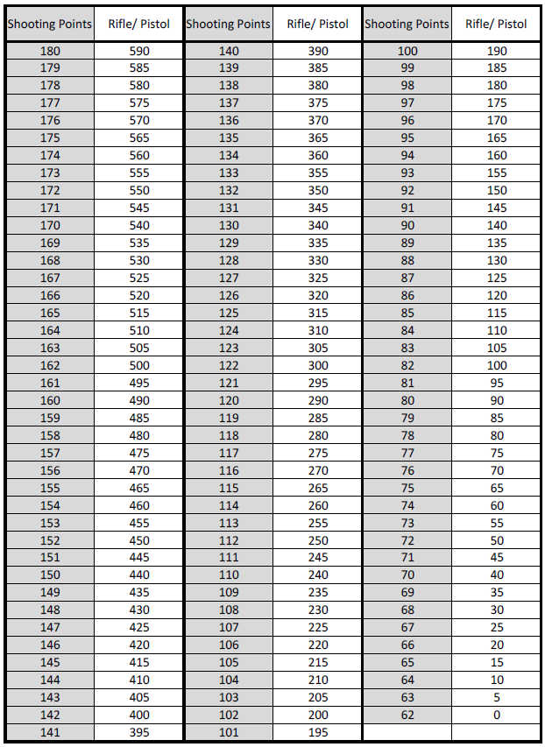
Team points:
The score of all three shooters will be added together to obtain the Team’s Competition points for that particular weapon.
This will be done for each weapon (rifle and pistol). The highest possible number of competition points for a team will therefore be:
(590 + 590 + 590) (Rifle) + (590 + 590 + 590) (Pistol) = 3540

APPENDIX 1 A: SHOOTING TARGETS AND SILHOUETTE
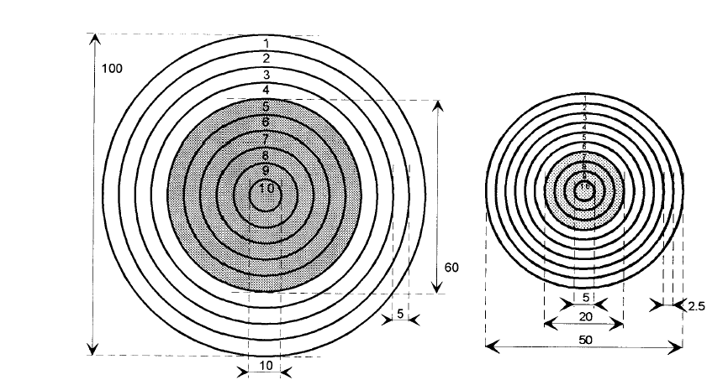
Target no. 1
Target no. 2
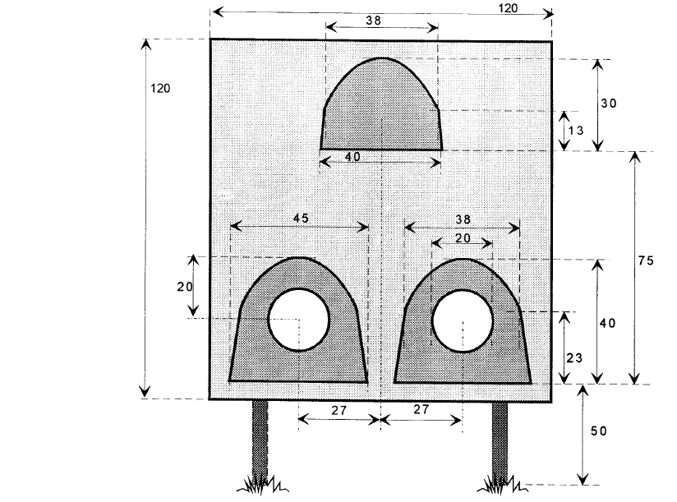
Target no. 4
Target no. 3
APPENDIX 1 B: DISC MARKING
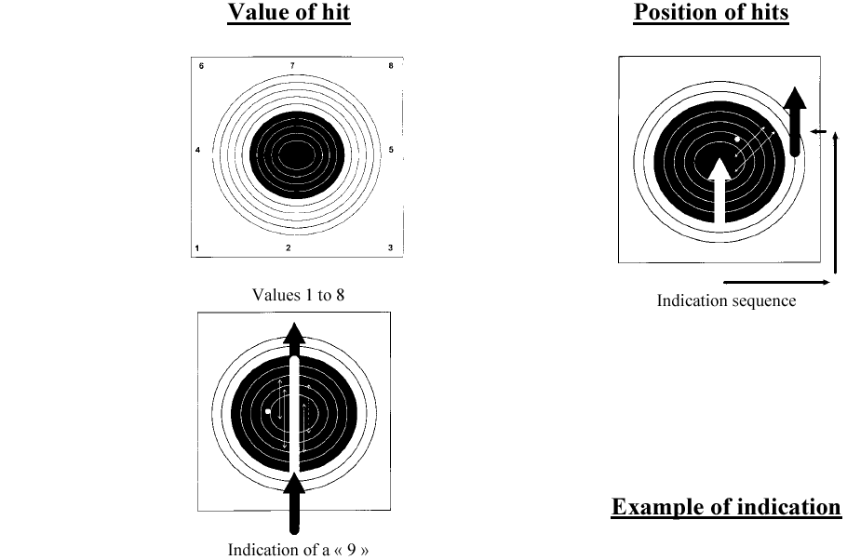
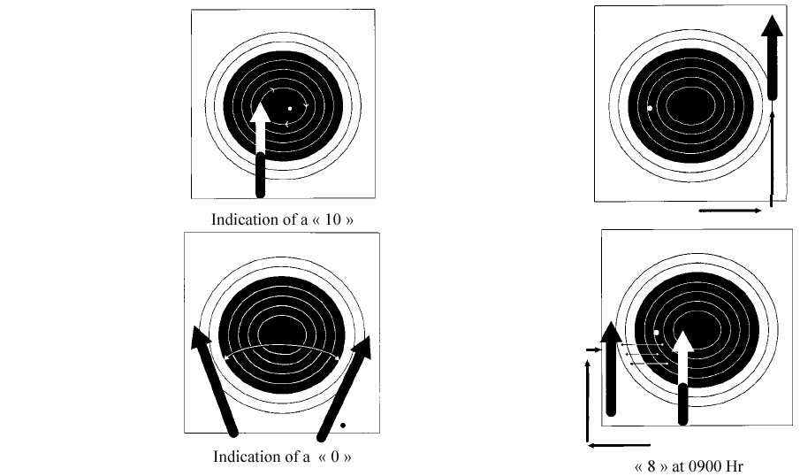
APPENDIX 2: LAND OBSTACLE COURSE
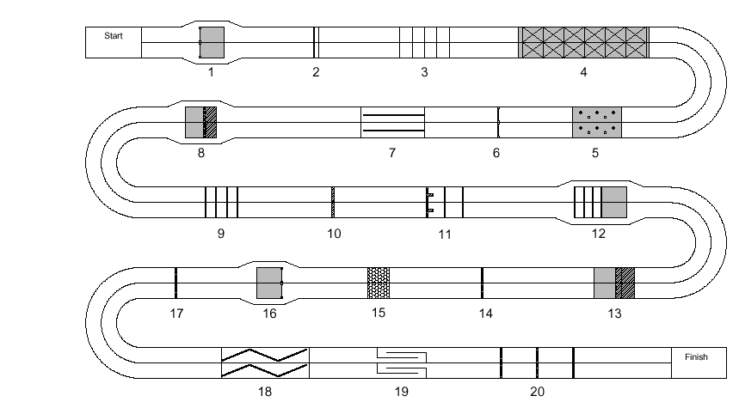

Detailed Obstacle Course (two lanes shown)
OBSTACLE NO. 1 – ROPE LADDER OR SCALING NET
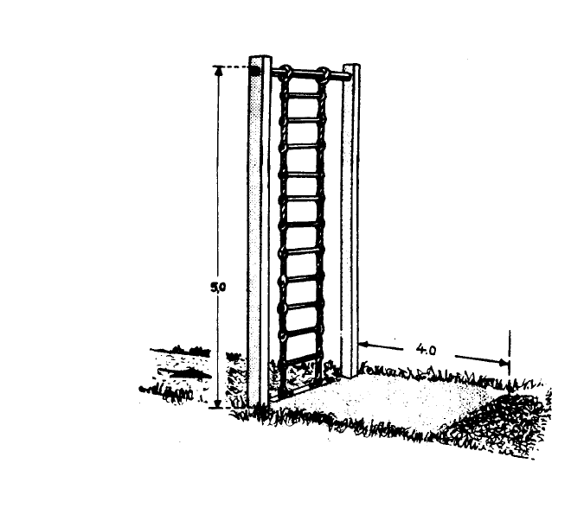
Characteristics: Fixed to the earth
Height 5.00 m
No. of steps 11
Width 0.50 m
Length of landing pit 4.00 m

Crossing: Free style climb, cross over the cross-beam and descend or jump to the other
side on the prepared earth.

OBSTACLE NO. 2 – DOUBLE BEAM
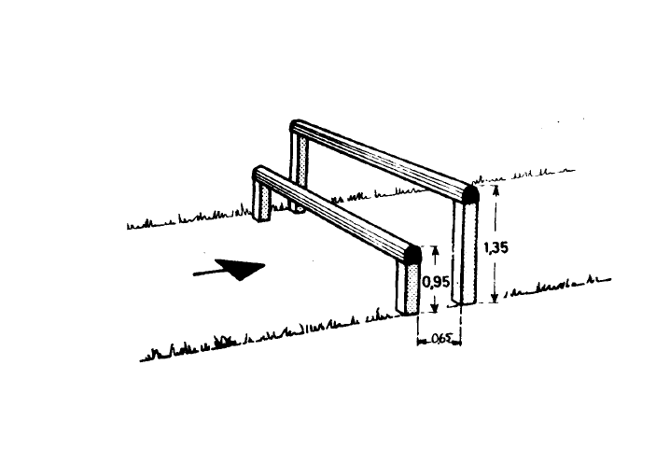

Characteristics: 1st beam height 0.95 m,
2nd beam height 1.35 m.
Distance between beams (horizontal plane) 0.65 m.

Crossing: Pass over the first beam, make contact with the earth on the other side,
then pass over the second.

OBSTACLE NO. 3 – NETWORK OF WIRES (TO BE HURDLED)
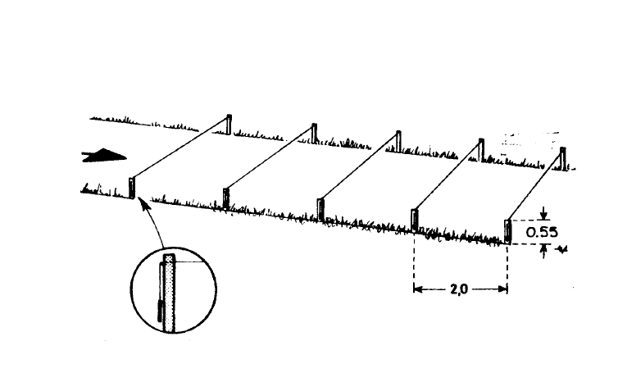

Characteristics: 5 smooth wires or elastic cords, coloured or marked to make them very visible,
loosely fixed at 0.55 m height and 2.00 m distance.
Diameter of wires minimum 7 mm.

Crossing: Network of wires to be hurdled. Jump over each of 5 wires successively and in free
style. Even if a competitor touches or breaks the wires the crossing is valid.

OBSTACLE NO. 4 – NETWORK TO BE CROSSED BY CRAWLING
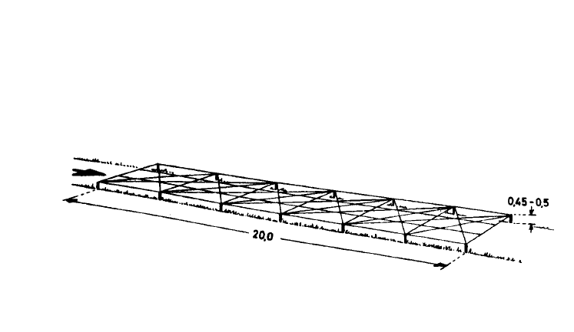

Characteristics: Length of network 20 m.
Maximum height 0.45 - 0.50 m.
The network must be fixed and be of non-stretchable material.

Crossing: Network must be crossed by crawling.
Crawling style at the competitor’s choice.

OBSTACLE NO. 5 – FORD (ELEPHANT FEED)
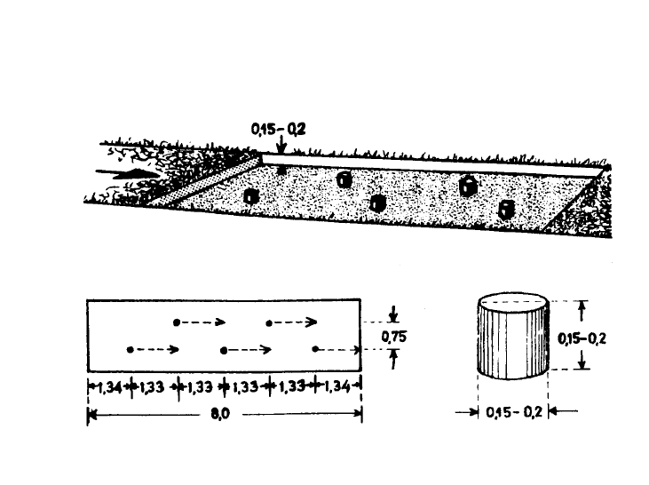

Characteristics: Height 0.15 - 0.20 m
Diameter 0.15 - 0.20 m
Length of the cord 8.00 m.

Crossing: It is forbidden to touch the ground between the pots in the space between the two
lines limiting the ford.
To “touch” means to take support. In the case of contact with the ground the
competitor must recommence at the first line.
There is no obligation to use all the pots.

OBSTACLE NO. 6 – GATE (SWEDISH RACK)
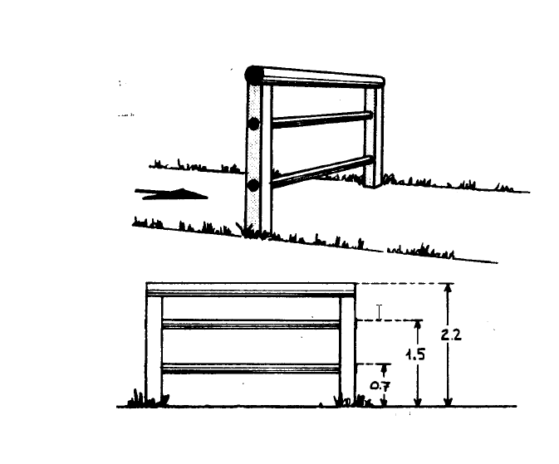

Characteristics: 3 Horizontal bars,
highest bar height 2.20 m,
second bar height 1.50 m,
lowest bar height 0.70 m.

Crossing: All styles are permitted on condition that the highest beam is crossed.

OBSTACLE NO. 7 – BALANCING BEAM
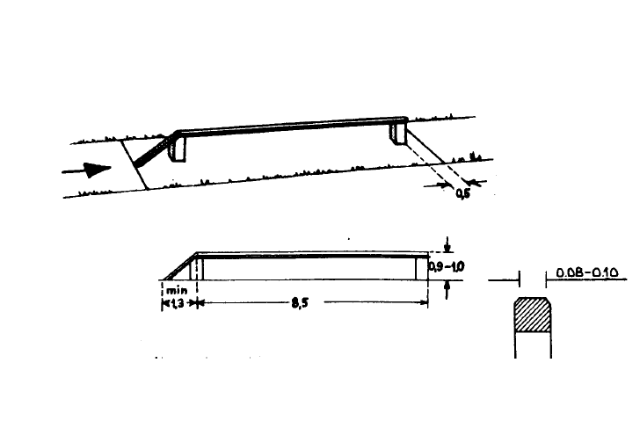

Characteristics: Height 0.90 - 1.00 m
Length 8.50 m
Diameter 0.20 - 0.25 m
The beam may be round.
Two lines will mark the limits of the obstacle; one at the beginning of the inclined
plane, the other at about 0.50 m beyond the end of the beam.

Crossing: Mount the beam by the inclined plane, or without help of it, and cross it. Then jump
to the ground beyond of the line. Between the two lines all contact with the ground
is considered a fault. The competitor must recommence from before the first line.

OBSTACLE NO. 8 – SLOPING WALL WITH ROPE
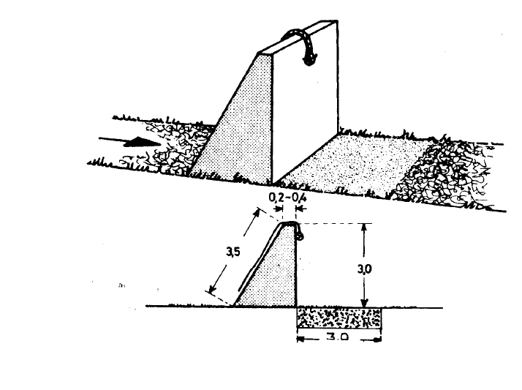

Characteristics: Height 3.50 m along a steeply inclined plane. Maximum jumping height 3.00 m.

Crossing: Free style climb with or without using the rope. Cross over the top and jump down
on the prepared earth on the opposite side.

OBSTACLE NO. 9 – HORIZONTAL BEAMS OVER AND UNDER
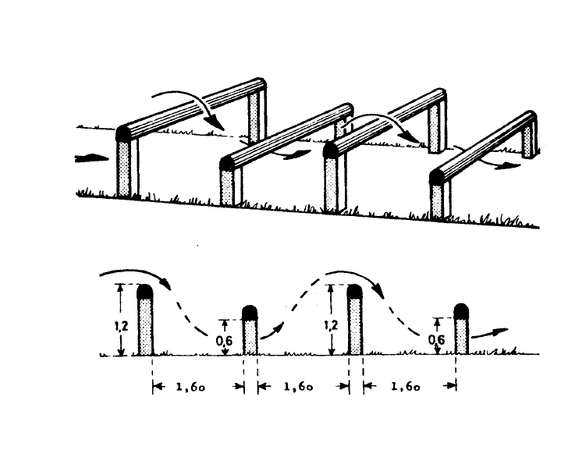

Characteristics: Respective height of the beams 1.20 - 0.60 - 1.20 - 0.60 m. Distance between the
beams (horizontal plane) 1.60 m.

Crossing: Tackle the beams in the following order: Over - under - over - under in a style left to
the competitor’s choice.

OBSTACLE NO. 10 – IRISH TABLE
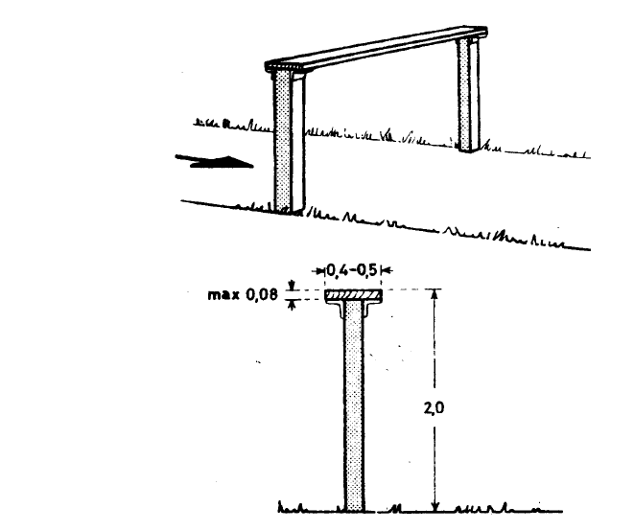

Characteristics: Height 2.00 m
Width 0.40 - 0.50 m

Crossing: All styles are permitted under the condition that the competitor does not use the
uprights and passes over the obstacle in the course direction. To use means to
take support.

OBSTACLE NO. 11 – TUNNEL AND TWIN BEAMS (FOX HOLE)
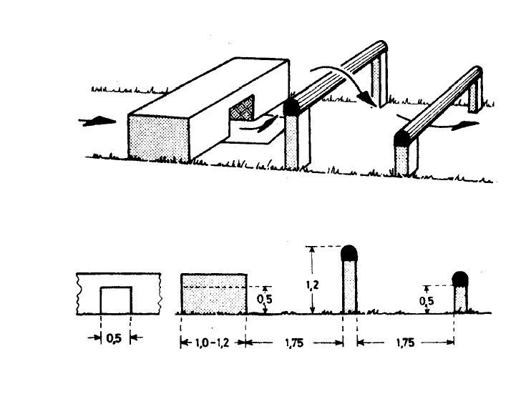

Characteristics: Tunnel of 0.50 m width and 1.10 m in length. Height of the beams: first 1.20 m,
second 0.50 m. Distance between the various parts of the obstacle 1.75 m.
It is permitted to prepare the surface of the tunnel in order to facilitate passing
through.

Crossing: Tackle in the following order: Through, over, under.

OBSTACLE NO. 12 – FOUR STEPS OF BEAMS (CHICKEN LADDER)
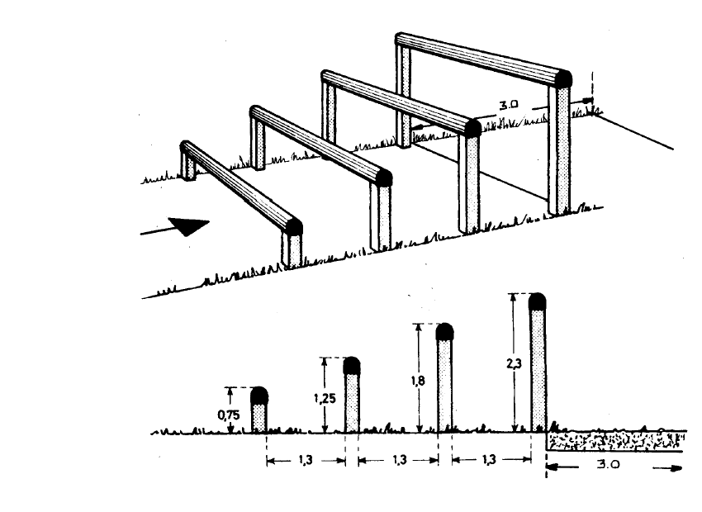

Characteristics: Height of 1st beam 0.75 m
Height of 2nd beam 1.25 m
Height of 3rd beam 1.80 m
Height of 4th beam 2.30 m
Length of landing pit 3.00 m
A wooden plank (0.30 – 0.60 m wide and about 5 cm thick) covering from the 1st
step to the 4th step will be added; the plank will be fixed preferably under the steps.
The plank will be set on the exterior corridor in order not to get in other competitor's
way.

Crossing: Climb in free style with the condition that at least one foot touches each of the
beams, except the fourth.
Only female competitors will be allowed to use the plank to cross the obstacle. For
each female member (including females in a mixed team) not using the plank a bonus of 10 seconds will be deducted (maximum of 30 seconds) from the team's running time. If a male competitor uses the plank, it will be considered as a fault and he will have to repeat the obstacle.

OBSTACLE NO. 13 – BANQUETTE AND PIT
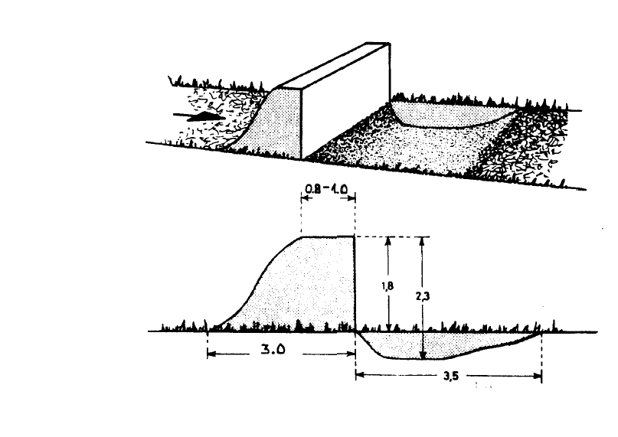

Characteristics: Height 1.80 m
Depth 2.30 m
Width of the pit 3.50 m
Width of the banquette 1.00 m

Crossing: Free style crossing.

OBSTACLE NO. 14 – LOW WALL
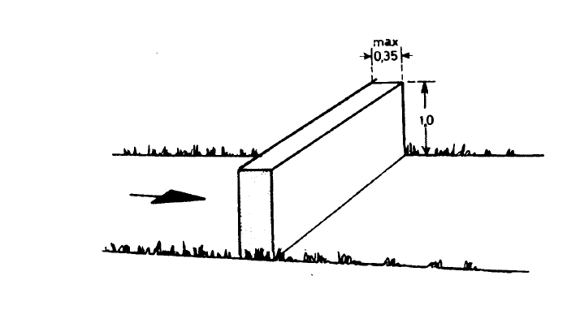

Characteristics: Height 1.00 m
Max. width 0.35 m

Crossing: Free style crossing.

OBSTACLE NO. 15 – (BEAR) PIT
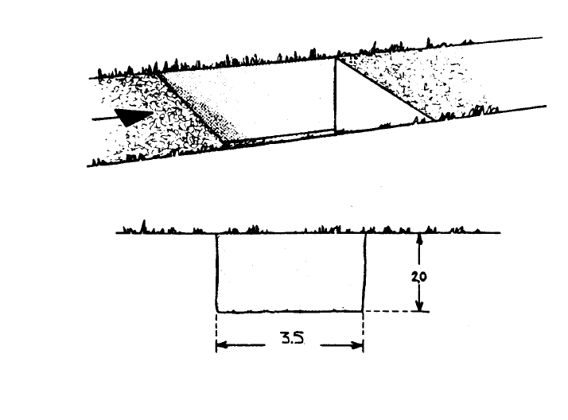

Characteristics: Depth 2.00 m
Length 3.50 m
The pit’s walls are perpendicular. The track above is horizontal and not giving the
possibility to have a hold on it. The track above the exit end is horizontal and does
not give the possibility of having a hold on it.

Crossing: Jump into the pit, then climb out without using the angles or the sides.

OBSTACLE NO. 16 – VERTICAL LADDER
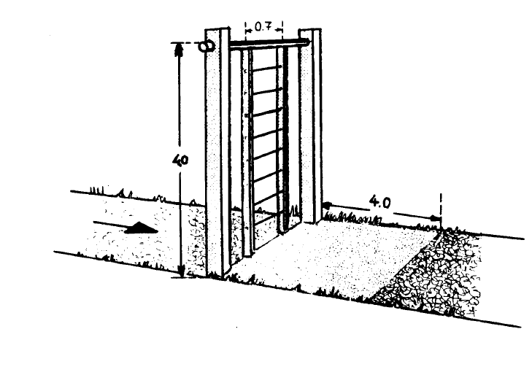

Characteristics: Height 4.00 m
No. of steps 8
Width 0.70 m
Length of landing pit 4.00 m

Crossing: Independent climb, cross over the cross beam and descend or jump down on the
opposite side on prepared earth.

OBSTACLE NO. 17 – HIGH WALL
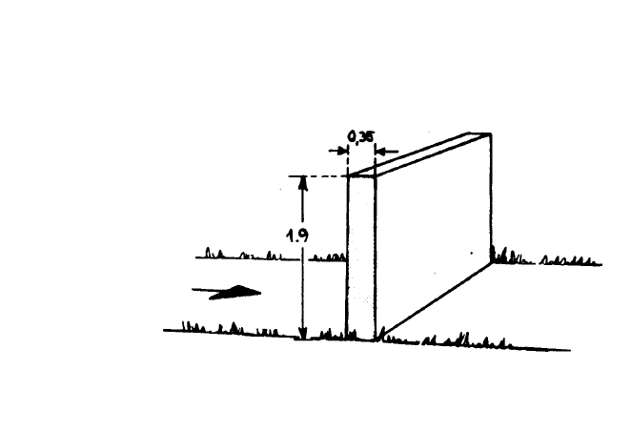

Characteristics: Height 1.90 m
Max. width 0.35 m

Crossing: Free style crossing.

OBSTACLE NO. 18 – BALANCE BEAMS
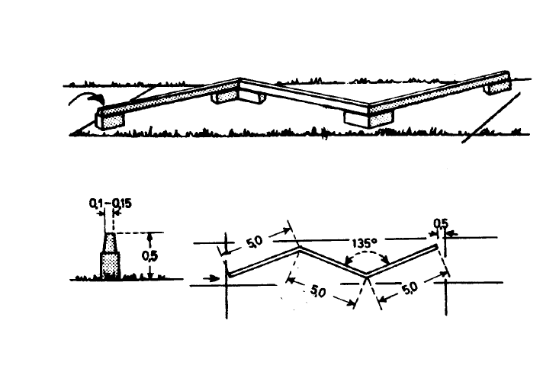

Characteristics: Height 0.50 m
Total length 15 m
Width 0.10 - 0.15 m
An angle of 135° between the beams. Two lines will mark the obstacle-limits; one
will be placed at the start of the obstacle, the other at about 0.50 m beyond the end.

Crossing: Mount the beam. Pass along the three beams, then jump to the ground ahead of
the traced line. Between the two lines all contact with the ground is considered a
fault. The competitor must recommence from before the first line.

OBSTACLE NO 19 – CHICANES (TICKET COUNTER)
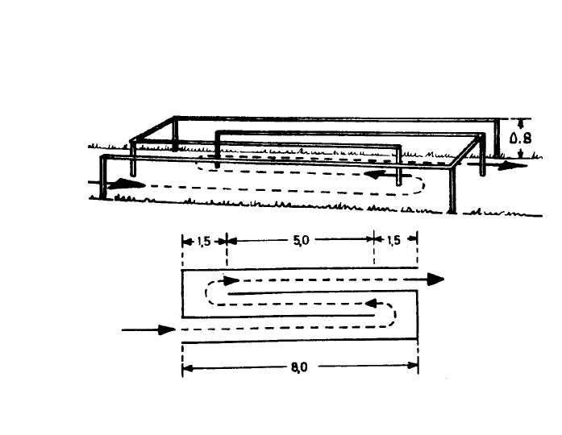

Characteristics: Length 8.00 m
Distance of run 18 m

Crossing: Normal run into the chicane with or without using the uprights.

OBSTACLE NO 20 – THREE ASSAULT WALLS
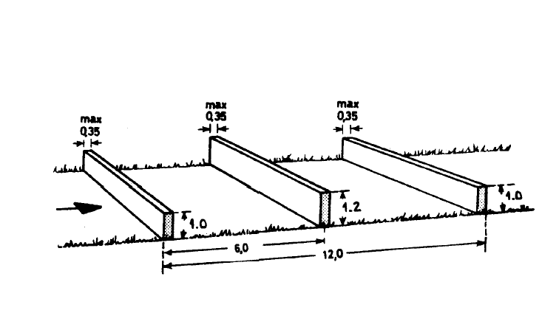

Characteristics: Height of 1st wall 0.85 - 1.00 m
Height of 2nd wall 1.10 - 1.20 m
Height of 3rd wall 0.85 - 1.00 m
Max. width of walls 0.35 m
Total length 12 m

Crossing: To be tackled in succession at the competitor’s choice on the condition of touching
the bottom of each trench or passing over three walls.

APPENDIX 3 A: UTILITY SWIMMING – DESCRIPTION OF OBSTACLES

OBSTACLE NO. 1

Characteristics: Two poles (minimum diameter 15 cm, completely fixed at the side, in a floating
position, placed perpendicularly to the corridor with a spacing of 3 m.
Crossing: Pass over the first obstacle and under the second.

OBSTACLE NO. 2

Characteristics: A raft 3 m long in floating position, completely fixed. Thickness of the raft at the
entrance and the exit 0.05 - 0.10 m.
Crossing: Pass under the raft.

OBSTACLE NO. 3

Characteristics: A platform of planks covered with carpet. Height of the platform from above the surface of the water must be between 45 cm to 55 cm.
1.20 m (width tolerance between 1.15 and 1.25 m).
Crossing: Pass over the platform.

OBSTACLE NO. 4

Characteristics: A pole (minimum diameter 15 cm) completely fixed in a floating position. However,
this pole may be slightly mobile in the vertical direction.
Crossing: Pass under the pole and finish the race.

APPENDIX 3 B: UTILITY SWIMMING – LAYOUT OF OBSTACLES

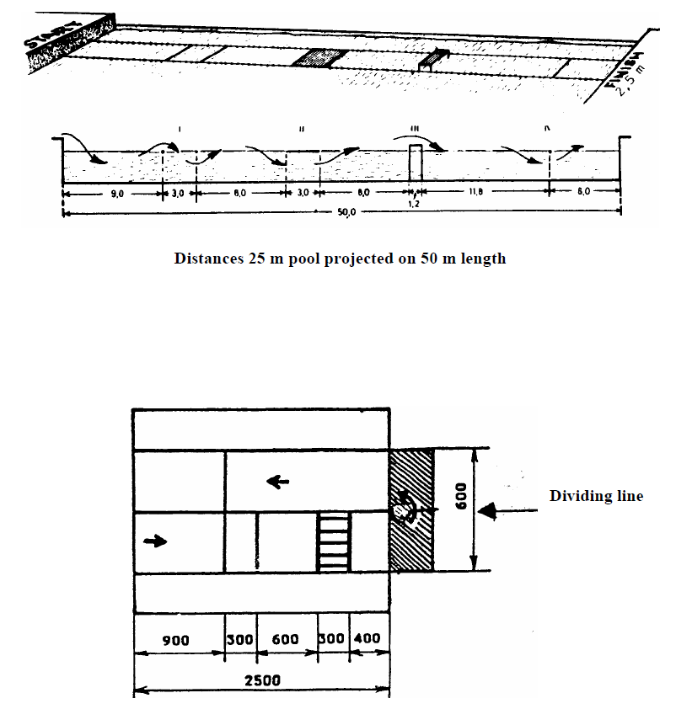
Layout of 50 m pool obstacles
,
,
,
,
,
,
,
APPENDIX 4 A: HAND GRENADE THROWING
Layout of 25 m pool obstacles
DIMENSIONS AND POSITIONS OF TARGETS
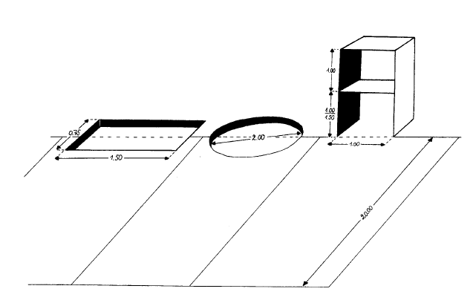

APPENDIX 4 B: HAND GRENADE THROWING
INDICATIONS OF HITS
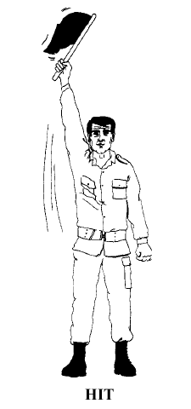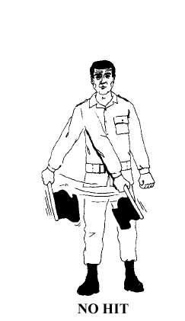

APPENDIX 5: PROTEST FORM
CIOR Milcomp
Protest Form

Team No: Date:
Competitors Name: Time:

Protest (continue on reverse side if necessary)

Competitors Signature:
-------------------------------------------------------------------------------------------------------------------------------
Head of Delegation: Date:
Country: Time:

Elaboration on protest (only if necessary)

Head of Delegation Signature:
Or Deputy (if Deputy print name and position):
-------------------------------------------------------------------------------------------------------------------------------

Decision of Technical Jury

Head of Delegation (or Deputy) and competitor debriefed on decision
Date:
Time:
Head of TJ Signature:
APPENDIX 6 A COMBAT DRESS FOR LOC

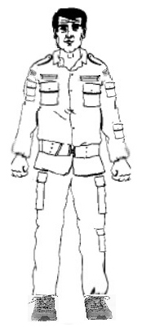

Combat jacket with ranks, collar, long sleeves,
any boots or running shoes.
(large combat belt not needed for LOC)

APPENDIX 6 B COMBAT DRESS FOR MOM

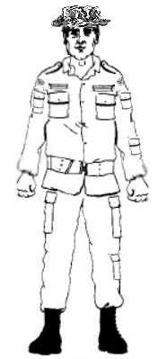

Military boots, combat jacket with ranks, collar,
long sleeves, military hat (hat, cap or beret),
long legged pants with military belt.
(large combat belt over jacket not necessary for MOM)

APPENDIX 7 MILITARY BOOTS FOR MOM
(ALLOWED , NOT ALLOWED X)

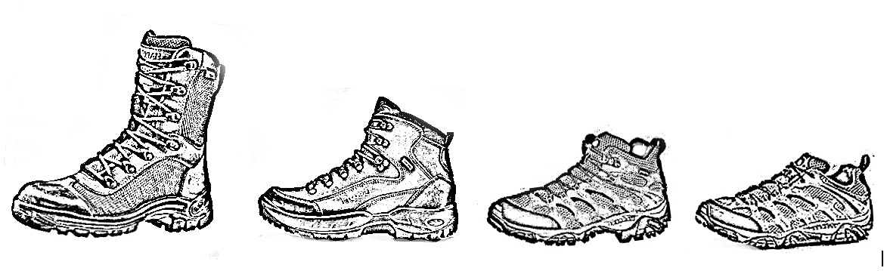

X
X
High cut Mid Cut II Mid Cut I Low Cut

APPENDIX 8: COMMANDS: RIFLE SHOOTING

Rifle: Trial Fire
# | Commands | Duration | Actions by Officials | Actions by Competitors
1 | "Competitors, take your position, fill magazine." | Until the range officer is satisfied that all competitors are in the right position and they all have ammunition. (3 min) | Ready with namelist to confirm that the competitor is in the correct shooting point. Ammunition is handed to the competitor. | Move to the shooting line and wait for the official to confirm you are in the correct shooting point. Fill your magazine.
2 | "200 meters rifle trial fire. 5 Rounds in 5 minutes.  No indication of shots." Alternative: "Each round to be indicated."  "Load and make ready your weapons." | 30 seconds | Take position behind the competitors. | Put magazine on the weapon, cock the weapon and get ready to fire.
3 | "Competitors, get ready to fire, line ready."  If line is not ready: "Line not ready" Wait 10 sec, then "Line is ready”. No more indication of "not ready" by competitors. | 10 Seconds | Keep position behind the competitors. | Wait for command to fire. You must be ready to fire at this point no further waiting will be allowed.  Competitors can say "Not Ready"; ONLY ONCE PER DETAIL.
4 | "Seconds 5-4-3-2-1" SIGNAL | 5 seconds | Check any person firing before the SIGNAL. | Fire only, once the SIGNAL starts.
5 | No Commands. | 4 minutes 57 seconds | Assist competitors where needed. | Shoot.
6 | SIGNAL for 3 seconds. | 3 seconds | Check if any competitor fires a shot after the end of the SIGNAL. As this is trail fire shots after the SIGNAL will carry no penalty but the competitor must be made aware that a shot was fired out of the time allocated. | Keep on firing until the SIGNAL stops. Thus it means that whilst the SIGNAL sounds for 3 seconds you may still fire rounds.
7 | "Prepare weapon for inspection”. | Unlimited (2 min) | Official checks to ensure weapon is empty and on safe. | Competitors presents weapon for inspection.

Rifle: Precision Fire
# | Commands | Duration | Actions by Officials | Actions by Competitors
1 | "Competitors take your position and fill the magazine." | Unlimited (3 min) | Take position behind the competitors. | Take positions. Fill your magazine.
2 | "200 meters rifle precision fire. 9 rounds in 5 minutes.  No indication of shots.  Load and make ready your weapons." | 30 seconds | Keep position behind the competitors. | Put magazine on the weapon, cock the weapon and get ready to fire.
3 | "Competitors, get ready to fire, line ready."  If line is not ready: "Line not ready" Wait 10 sec, then "Line is ready”. No more indication of "not ready" by competitors. | 10 Seconds | Keep position behind the competitors. | Wait for command to fire. You must be ready to fire at this point no further waiting will be allowed.  Competitors can say "Not Ready"; ONLY ONCE PER DETAIL.
4 | "Seconds 5-4-3-2-1" SIGNAL | 5 seconds | Check any person firing before the SIGNAL. | Fire only, once the SIGNAL starts.
5 | No Commands. | 4 minutes 57 seconds |  | Shoot.
6 | SIGNAL for 3 seconds. | 3 seconds | Check if any competitor fires a shot after the end of the SIGNAL. If any competitor fired a shot after the end of the SIGNAL indicate this to the range officer. | Keep on firing until the SIGNAL stops. Thus it means that whilst the SIGNAL sounds for 3 seconds you may still fire rounds.
7 | "Prepare weapon for inspection”. | Unlimited (2 min) | Official checks to ensure weapon is empty and on safe. | Competitors present weapons for inspection.

Rifle: Rapid Fire
# | Commands | Duration | Actions by Officials | Actions by Competitors
1 | "Competitors take your position and fill the magazine." | Unlimited (3 min) | Take position behind the competitors. | Take positions. Fill your magazine.
2 | "200 meters rifle rapid fire. 9 rounds in one minute.  Load & make ready your weapons." | 30 seconds | Keep position behind the competitors. | Put magazine on the weapon. Cock the weapon and get ready to fire.
3 | "Competitors, get ready to fire, line ready."  If line is not ready: "Line not ready" Wait 10 sec, then "Line is ready”. No more indication of "not ready" by competitors. | 10 Seconds | Keep position behind the competitors. | Wait for command to fire. You must be ready to fire at this point no further waiting will be allowed.  Competitors can say "Not Ready"; ONLY ONCE PER DETAIL.
4 | "Seconds 5-4-3-2-1" SIGNAL | 5 seconds | Check any person firing before the SIGNAL | Fire only, once the SIGNAL starts.
5 | No Commands. | 57 seconds |  | Shoot.
6 | SIGNAL for 3 seconds. | 3 seconds | Check if any competitor fire a shot after the end of the SIGNAL. If any competitor fired a shot after the end of the SIGNAL indicate this to the range officer. | Keep on firing until the SIGNAL stops. Thus it means that whilst the SIGNAL sounds for 3 seconds you may still fire rounds.
7 | "Prepare weapon for inspection.” | Unlimited (2 min) | Official checks to ensure weapon is empty and on safe. | Competitors present weapons for inspection.

APPENDIX 9: COMMANDS: PISTOL SHOOTING

Pistol: Trial Fire
# | Commands | Duration | Actions by Officials | Actions by Competitors
1 | "Competitors, take your position, fill magazine." | Until the range officer is satisfied that all competitors are in the right position and they have ammunition.  (3 min) | Ready with name list to confirm that the competitor is in the correct shooting point. Ammunition is handed to the competitor. | Move to the shooting line and wait for the official to confirm you are in the correct shooting point. Fill your magazine.
2 | "25 meters pistol trial fire. 5 Rounds in 3 minutes.  Load & make ready your weapons." | 30 seconds | Take position behind the competitors. | Put magazine on the weapon, cock the weapon, and get ready to fire.
3 | "Competitors, get ready to fire, line ready."  If line is not ready: "Line not ready" Wait 10 sec, then "Line is ready”. No more indication of "not ready" by competitors | 10 Seconds | Keep position behind the competitors. | Wait for command to fire. You must be ready to fire at this point no further waiting will be allowed. Competitors can say "Not Ready"; ONLY ONCE PER DETAIL.
4 | "Seconds 5-4-3-2-1" SIGNAL | 5 seconds | Check any person firing before the SIGNAL. | Fire only, once the SIGNAL starts.
5 | No Commands | 2 minutes 57 |  | Shoot
6 | SIGNAL for 3 seconds. | 3 seconds | Check if any competitor fires a shot after the end of the SIGNAL. As this is trail fire shots after the SIGNAL will carry no penalty but the competitor must be made aware that a shot was fired out of the time allocated. | Keep on firing until the SIGNAL stops. Thus it means that whilst the SIGNAL sounds for 3 seconds you may still fire rounds.
7 | "Prepare weapon for inspection”. | Unlimited (2 min) | Official checks to ensure weapon is empty and on safe. | Competitors present weapons for inspection.

Pistol: Precision Fire (Part One)
# | Commands | Duration | Actions by officials | Actions by Competitors
1 | "Competitors, take your position, fill both magazines with at least 4 rounds”. | Unlimited (3 min) | Take position behind the competitors. | Take positions. Fill your magazine.
2 | "25 meters pistol precision fire.  2 seperate series, 4 or 5 rounds each in one minute.  Load and make ready your weapons". | 30 seconds | Keep position behind the competitors. | Put 1st magazine on the weapon, cock the weapon, and get ready to fire.
3 | "Competitors, get ready to fire, line ready."  If line is not ready: "Line not ready" Wait 10 sec, then "Line is ready". No more indication of "not ready" by competitors | 10 Seconds | Keep position behind the competitors. | Wait for command to fire. You must be ready to fire at this point no further waiting will be allowed. Competitors can say "Not Ready"; ONLY ONCE PER DETAIL.
4 | "Seconds 5-4-3-2-1” SIGNAL. | 5 seconds | Check any person firing before the SIGNAL. | Fire only, once the SIGNAL starts.
5 | No Commands | 57 seconds |  | Shoot
6 | SIGNAL for 3 seconds. | 3 seconds | Check if any competitor fires a shot after the end of the SIGNAL. If any competitor fired a shot after the end of the SIGNAL indicate this to the range officer. | Keep on firing until the SIGNAL stops. Thus, it means that whilst the SIGNAL sounds for 3 seconds you may still fire rounds.

Pistol: Precision Fire (Part Two)
# | Commands | Duration | Actions by officials | Actions by Competitors
1 | "25 meters pistol precision fire. Second series 4 or 5 rounds in one minute. Load & make ready your weapons." | 30 seconds | Take position behind the competitors. Official to ensure that competitors do not pick up any ejected round during the loading process. | Already in position, put the 2nd magazine on the weapon, cock the weapon, and get in position to fire. If round is ejected during the loading process, competitor not allowed to pick it up.
2 | "Competitors, get ready to fire, line ready."  If line is not ready: "Line not ready" Wait 10 sec, then "Line is ready". No more indication of "not ready" by competitors. | 10 Seconds | Keep position behind the competitors. | Wait for command to fire. You must be ready to fire at this point no further waiting will be allowed. Competitors can say "Not Ready"; ONLY ONCE PER DETAIL.
3 | "Seconds 5-4-3-2-1” SIGNAL. | 5 seconds | Check any person firing before the SIGNAL. | Fire only, once the SIGNAL starts.
4 | No Commands. | 57 seconds |  | Shoot
5 | SIGNAL for 3 seconds. | 3 seconds | Check if any competitor fires a shot after the end of the SIGNAL. If any competitor fired a shot after the end of the SIGNAL indicate this to the range officer | Keep on firing until the SIGNAL stops. Thus it means that whilst the SIGNAL sounds for 3 seconds you may still fire rounds.
6 | "Prepare weapon for inspection." | Unlimited (2 min) | Official checks to ensure weapon is empty and on safe. | Competitors present weapons for inspection.

Pistol: Rapid Fire
# | Commands | Duration | Actions by officials | Actions by Competitors
1 | "Competitors, take your position, fill the magazines. One magazine must contain at least 2 rounds. " | Unlimited (3 min) | Take position behind the competitors. | Take positions. Fill two magazines; each magazine must contain at least two rounds.
2 | "25 meters pistol rapid fire.  9 rounds in 2 magazines in 35 seconds. Load & make ready your weapons." | 30 seconds | Keep position behind the competitors ensure each competitors have two magazines. | Already in position, put the 1st magazine on the weapon, cock the weapon and get ready to fire.
3 | "Competitors, get ready to fire, line ready."  If line is not ready: "Line not ready" Wait 10 sec, then "Line is ready". No more indication of "not ready" by competitors. | 10 Seconds | Keep position behind the competitors. | Wait for command to fire. You must be ready to fire at this point no further waiting will be allowed. Competitors can say "Not Ready"; ONLY ONCE PER DETAIL.
4 | "Seconds 5-4-3-2-1” SIGNAL. | 5 seconds | Check any person firing before the SIGNAL. | Fire only, once the SIGNAL starts.
5 | No Commands. | 32 seconds | Check competitors to see if magazine changes did take place. | Shoot. During the shooting, the competitor changes the magazines.
6 | SIGNAL for 3 seconds. | 3 seconds | Check if any competitor fires a shot after the end of the SIGNAL. If any competitor fired a shot after the end of the SIGNAL indicate this to the range officer. | Keep on firing until the SIGNAL stops. Thus it means that whilst the SIGNAL sounds for 3 seconds you may still fire rounds.
7 | "Prepare weapon for inspection." | Unlimited (2 min) | Official checks to ensure weapon is empty and on safe. | Competitors present weapons for inspection.

